Article ID: 7214
Article Name: How do I change/synchronize my remote control on my vacuum cleaner
Topic Location: Floorcare, bag/bagless cleaners, display controls.
Meta-data: changed, no contact, synchronize, unsynchronized
Related Articles:
Related Questions:
PNC
DIY
Safety
Link
Email
Book Engineer
Multimedia
Brand
Article Content:
If you need to change the remote control on your vacuum cleaner you also need to synchronize it with the receiver in the machine. To do that, follow the instructions for your model below.
Models that begin with z88xx and zus39xx:
- First check that the LED lamp on the remote control is illuminated when you press the buttons. If not, change the battery first before proceeding to the next step.
- Unplug your machine.
- Press and hold the On/Off button on your machine.
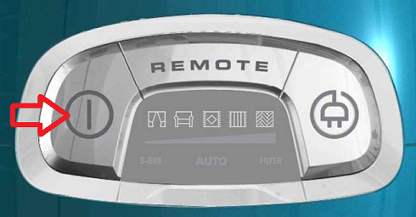 or 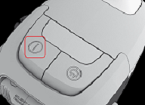
- Plug it in and wait until “AUTO” or “C” is illuminated in display.
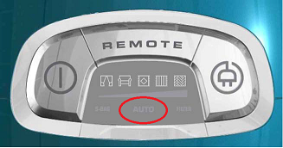 or 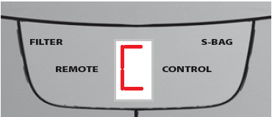
- Release the power button on the machine and then press start button on you remote control. Now all lights on the power meter or “L” should illuminate in display. 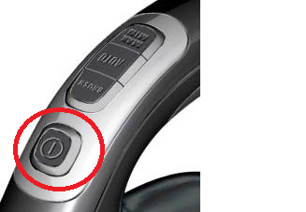
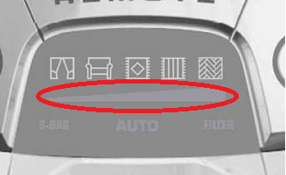 or 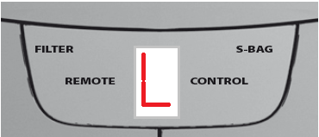
- Now you can restart you vacuum cleaner and everything should work as normal.

Models that begin with UO, US or UC:
- First check that the LED lamp on the remote control is illuminated when you press the buttons on the remote control. If not, change the battery first before proceeding to the next step.
- Plug in the unit to a power socket.

- Press the proper buttons at the same time (1+4). This must be done within 20 seconds after plugging in the cleaner. This erases the code from the system.
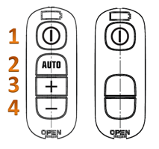
- Unplug the unit from power socket and wait 3 seconds.

- Plug in the unit to power socket again.

- Press the proper buttons at the same time ( 1+3 ) / it must be done within 20 seconds after plugging in the cleaner
- Now you can restart you vacuum cleaner and everything should work as normal.

